1st page

Hawaii To Mainland

1. Header picture will change

* Header headline will be “ Experience Your Vehicle Shipping To Hawaii From The Mainland Today” sub heading will remain same

1. Reviews
2. Our Services Explained same as it is
3. How Hawaii Car Transport Works. Just remove these heading from here and rest will remain same with a picture change only.

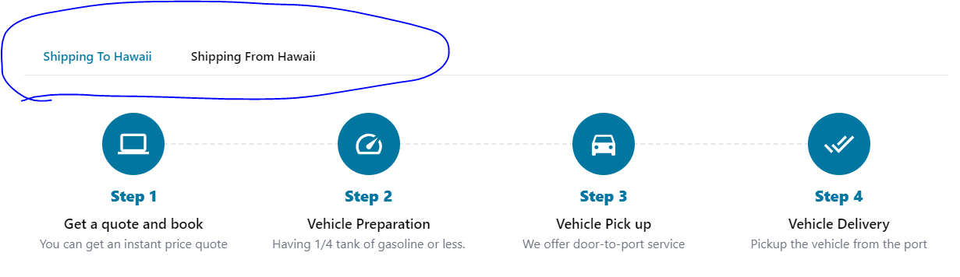

1. Packages same as it is
2. Our Active Ports same as it is
3. No Faqs

2nd Page

Mainland To Hawaii

1. Header Picture will change

* Header headline will go as “ Experience Your Vehicle Shipping To Mainland From Hawaii Today sub heading will be “ Worried about cost and safety of shipping your car to Mainland from Hawaii? We ensure safety and hassle-free shipping, so you can enjoy the benefits without burning a hole in your pocket!”

1. Reviews
2. Our Services Explained
3. How Hawaii Car Transport Works? We will use all data for shipping from Hawaii and remove the headings and change picture only.

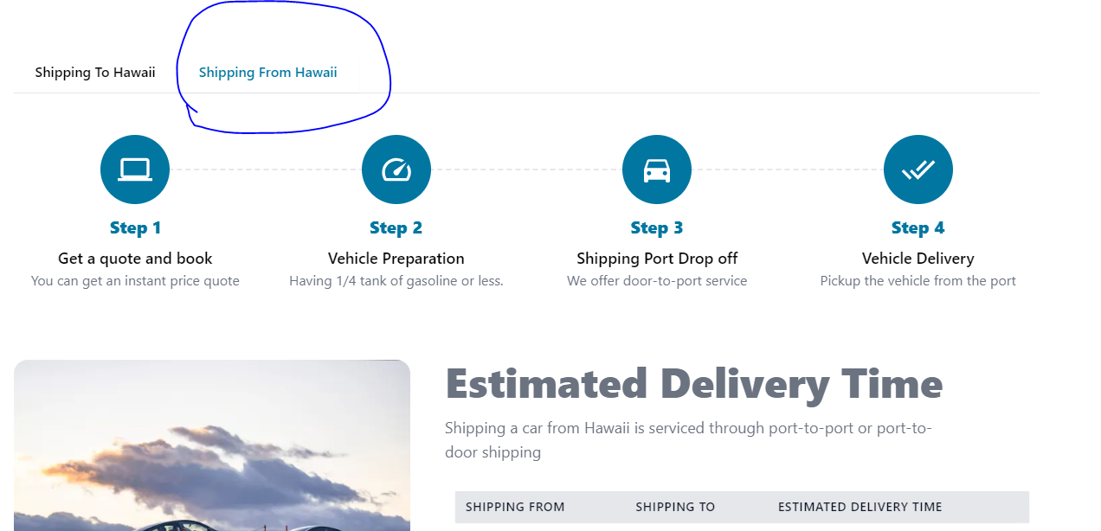

1. Packages
2. Our Active Ports
3. No Faqs